**Python Project : Youtube Video Downloader**

A very **Good Morning to all of you** !!.....Respected Teachers and my dear classmates…..

**Thanks to the Department of CSE for giving us a opportunity** to make a project and presents in front of us.

As we all have seen videos on YouTube, **some of the videos we wanna share to someone or watch it later without using the Internet. Then we need to download the same in our device**.

So to do that, we need a software to download it. **But in market, there are many software’s were there to do such task, but mostly they are paid, having issues with the server down, etc.**

So today we have come in front of you to solve this problem FREE OF COST. **The objective of this project is to download any kind of video in a fast and efficient way from YouTube in your device.**

To make that software, **we contribute our ideas in a group of 4 individuals (Aditya, Rajat, Gaurav and Ajay).**

We have made a software (**YouTube Video Downloader**) **using Python programming** language.

In this project, **user has to copy the URL of a video of YouTube** that they want to download and simply **paste that URL** in the **Paste Link Here** section and **click on the download button**, **it will start downloading the video**. **When video downloading finishes, it shows a message** **Downloaded** as a popup on the window below the download button.

**Steps to Develop this Project :**

These are the following steps to build youtube video downloader project using python:

* Import libraries
* Create display window
* Create field to enter link
* Create function to start downloading

**1. Import Libraries**

To implement this project, we use basic concepts and some libraries of python i.e. tkinter, pytube.

* **Tkinter** is a standard GUI library and it is one of the easiest way to build a GUI application in Python.
* **pytube** is used for downloading videos from the YouTube.

|  |
| --- |
| **pip install tkinter**  **Pip install pytube** |

To install the required modules/libraries, run pip installer command on the command line:

**2. Create Display Window**

|  |
| --- |
| **root = Tk()**  **root.geometry('500x300')**  **root.resizable(0,0)**  **root.title("DataFlair-youtube video downloader")** |

* **Tk()** is used to initialize tkinter to create the display of the window.
* **geometry()** is used to set the height and width of the window.
* **resizable(0,0)** is used to set the fix size of the window.
* **title()** is used to give the title of window.

|  |
| --- |
| **Label(root,text = 'Youtube Video Downloader', font ='arial 20 bold').pack()** |

* **Label()** widget used to display text that users can’t able to modify.
* **root** is the name of the window.
* **text** which we display the title of the label.
* **font** in which our text is written.
* **pack** is used to organized the widget in the block.

**3. Create Field to Enter Link**

|  |
| --- |
| **link = StringVar()**  **Label(root, text = 'Paste Link Here:', font = 'arial 15 bold').place(x= 160 , y = 60)**  **link_enter = Entry(root, width = 70,textvariable = link).place(x = 32, y = 90)** |

* **link** is a string type variable that stores the youtube video link that the user enters.
* **Entry()** widget is used when we want to create an input text field.
* **width** sets the width of entry widget
* **textvariable** used to retrieve the value of current text variable to the entry widget
* **place()** use to place the widget at a specific position

**4. Create Function to Start Downloading**

|  |
| --- |
| **def Downloader():**  **url =YouTube(str(link.get()))**  **video = url.streams.first()**  **video.download()**  **Label(root, text = 'DOWNLOADED', font = 'arial 15').place(x= 180 , y = 210)**  **Button(root,text = 'DOWNLOAD', font = 'arial 15 bold' ,bg = 'pale violet red', padx = 2, command = Downloader).place(x=180 ,y = 150)**  **root.mainloop()** |

Variable **url** gets the link of YouTube from the link variable by **get()** function and then **str()** will convert the link in **string** datatype.

Then the video is download in the first present stream of that video by **stream.first()** method.

* **Button()** widget is used to display button on the window.
* **text** which we display on the label.
* **font** in which the text is written.
* **bg** sets the background color.
* **command** is used to call the function.

**root.mainloop()** is a method that executes when we want to run the program.

**Output : YouTube Video Downloader**

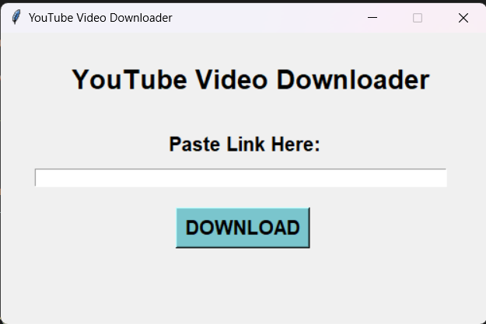

**Summary**

With this python project:

* We have successfully developed the **YouTube Video Downloader** project.
* We used the popular **Tkinter** library that used for rendering graphics.
* We use the **pytube** library to download videos from YouTube.